 | YEAR 12 MATHEMATICS SPECIALIST  SEMESTER ONE 2017  TEST 1: Complex Numbers

Name: _______________________
Thursday 9th March
Time: 55 minutes Mark /50 = %

- Answer all questions neatly in the spaces provided. Show all working.
- You are permitted to use the Formula Sheet in both sections of the test.
- You are permitted one A4 page (one side) of notes in the calculator assumed section.

Calculator free section Suggested time: 20 minutes /20

- [11 marks]

Determine each of the following in rectangular form
  - z if
[3]

[3]

  - one solution to
[2]

[3]

- [6 marks]

is a factor of.

  - Evaluate p
[2]

  - Rewrite in the form
[2]

  - Determine all solutions to
[2]

- 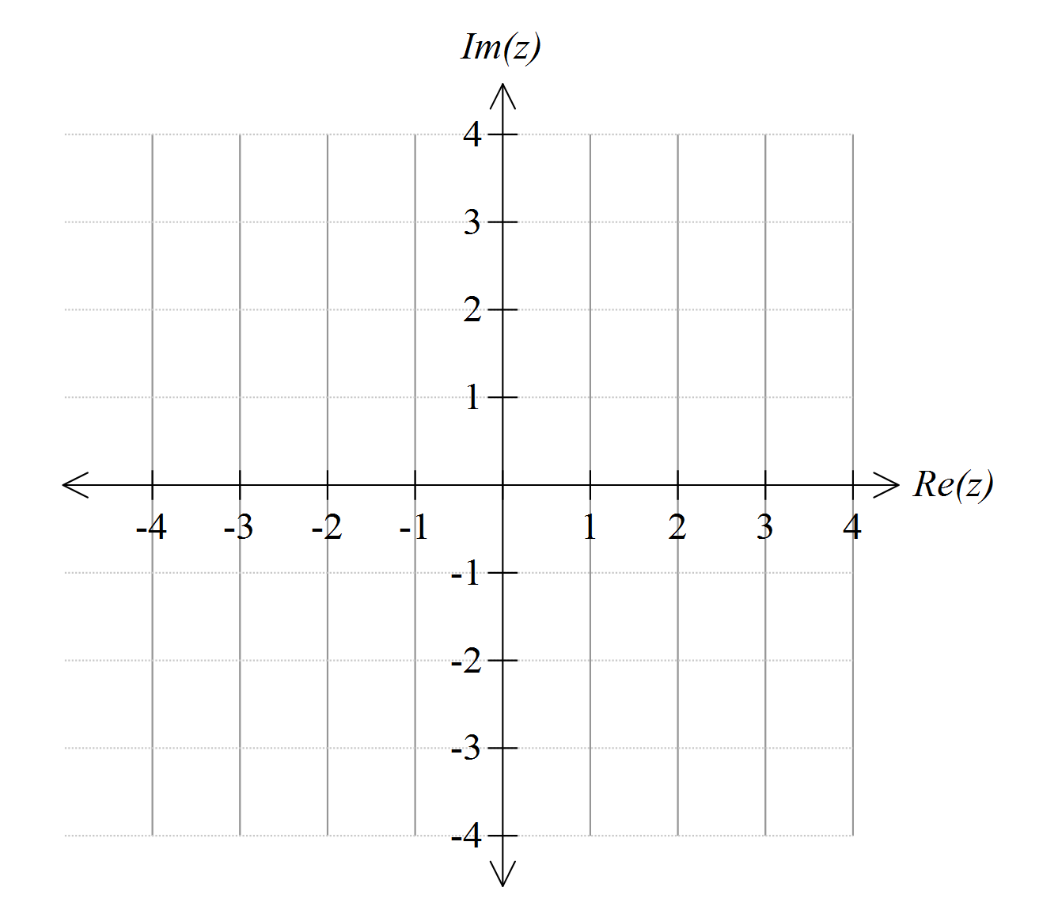 [3 marks]
When graphed on an Argand diagram, four of the solutions to form a square with vertices , , and .
Evaluate k and then write down the remaining solutions to

Calculator assumed section Suggested time: 35 minutes /30
Name: _______________________
- [4 marks]

and
For which values of n, , will be real?

- [4 marks]

Determine, in Cartesian form , all solutions to the equation

- [12 marks]
  - On the Argand diagrams given, sketch
(i) [2]
(ii) [4]


  - For the points defined in (i), determine the:
(iii) maximum value of arg(z) [1]

(iv) minimum value of arg(z) [3]

(v) maximum value of [2]

- [10 marks]
The line segments joining the points , and form a triangle whose interior satisfies two inequalities:
and

Determine:
  - the values of:
[2]
[2]
[2]
[2]

  - the area of triangle ABC
[2]

